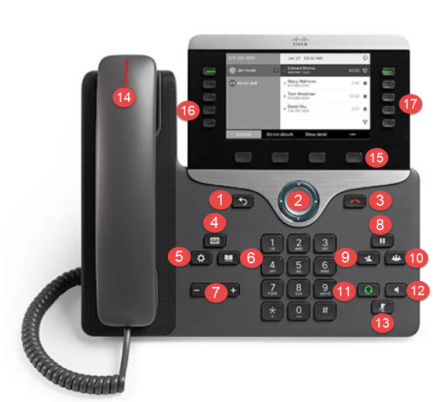

Phone Buttons:

- Back/Return
- Navigation
- Release/End Call
- Voicemail
- Applications/Settings
- Contacts/Directory
- Volume
- Hold
- Transfer
- Conference
- Headset
- Speakerphone
- Mute
- Incoming Call/Voicemail Indicator
- Softkeys
- Feature Buttons
- Session Buttons

Feature & Session Buttons Status’:
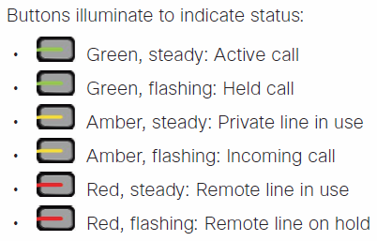

Listen to Voice Messages:
Requires a pin to have been previously setup through my.ciscospark.com
- Press MESSAGES
- Follow voice prompts
Transfer a Call to Another Person:

- From a call that is not on hold, Press TRANSFER
- Enter the other person’s phone number
- Press TRANSFER again
Transfer a Call to a Person’s Voicemail:

- From a call that is not on hold, Press TRANSFER
- Then *
- Then person’s extension
- Hang up
Put a Call on Hold:

- Press HOLD
- To resume a held call, press HOLD again
Conference/Add Another Person to a Call:

- From a connected call that is not on hold, Press CONFERENCE
- Press Active Calls to select a held call
- Press CONFERENCE again

Forward All Calls:

- Select a line and press FORWARD ALL from the softkeys
- Dial the number that you want to forward to, or press Voicemail key for all calls to go to voicemail
- To receive calls again, press Forward Off from the softkeys
Mute Calls:

- Press MUTE
- Press Mute again to turn mute off
Speakerphone Calls:

- Enter the phone number calling using the keypad
- Press SPEAKERPHONE or CALL from the softkeys
View Recent Calls:

- Press APPLICATIONS
- Select RECENTS
- Select a line to view
Change the Ringtone:

- Press APPLICATIONS
- Select Settings > Ringtone
- Select a line
- Scroll through the list of ringtones and press Play to hear a sample
- Press Set and Apply to save a selection
Adjust Screen Brightness:

- Press APPLICATIONS
- Select Settings > Brightness
- Press the Navigation cluster left to decrease, or right to increase brightness
- Press Save
Change Screen Font Size:

- Press APPLICATIONS
- Select Settings > Font Size
- Select a font size
- Press Save

